31. Implement a C Program to perform merge sort.

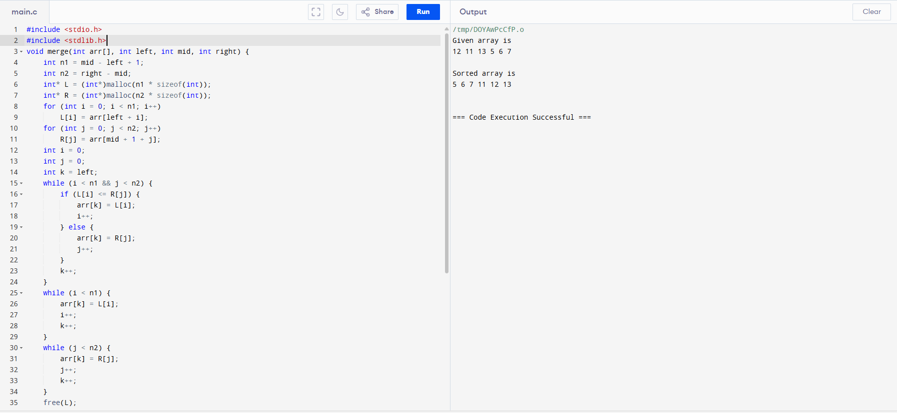

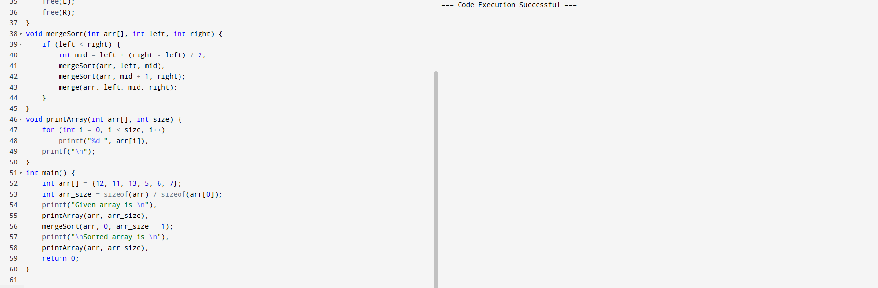

32. Implement a C Program to perform queue using two stacks

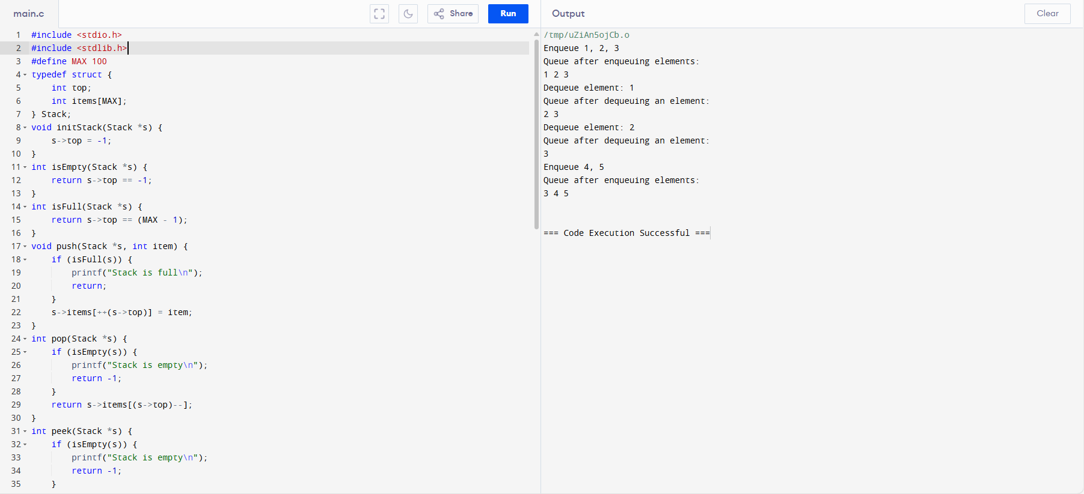

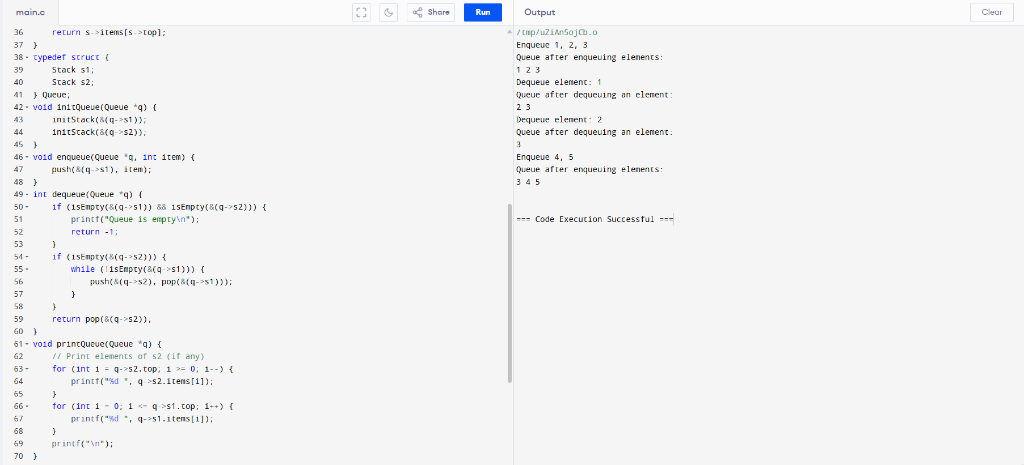

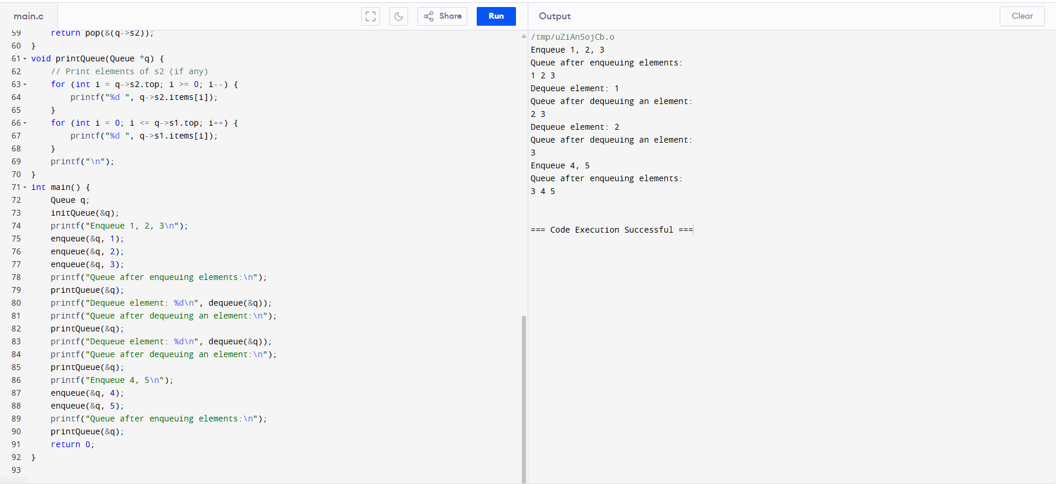

33. Implement a C Program to perform insertion sort.

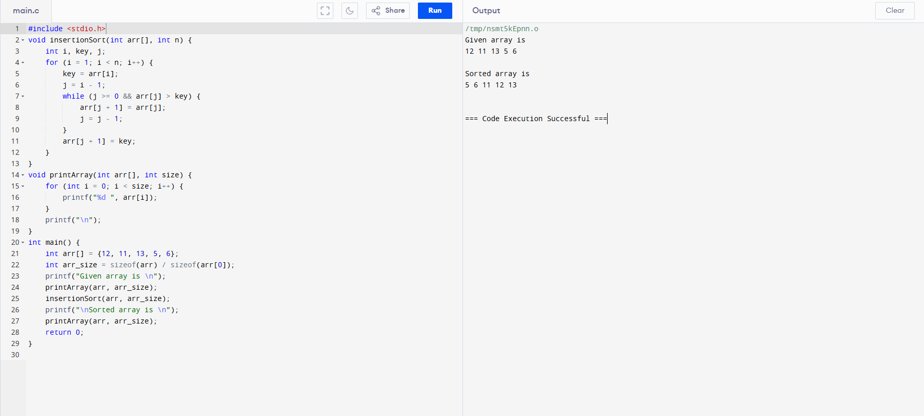

34. Implement a C Program to Intersect SLL.

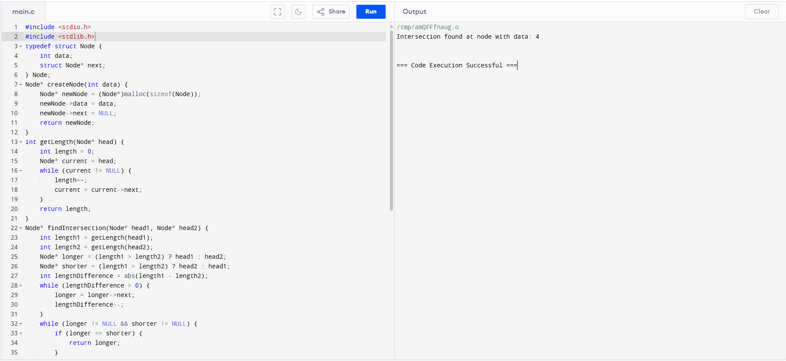

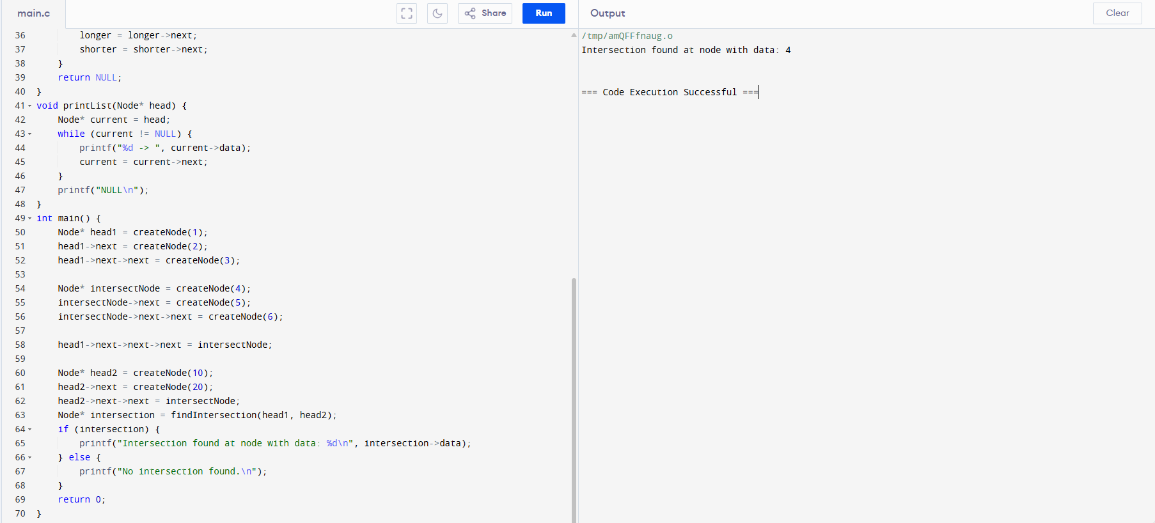

35. Write a program in C to merge two arrays of the same size sorted in descending order. Test Data : Input the number of elements to be stored in the first array :3 Input 3 elements in the array : element - 0 : 1 element - 1 : 2 element - 2 : 3 Input the number of elements to be stored in the second array :3 Input 3 elements in the array : element - 0 : 1 element - 1 : 2 element - 2 : 3 Expected Output : The merged array in descending order is : 3 3 2 2 1 1.

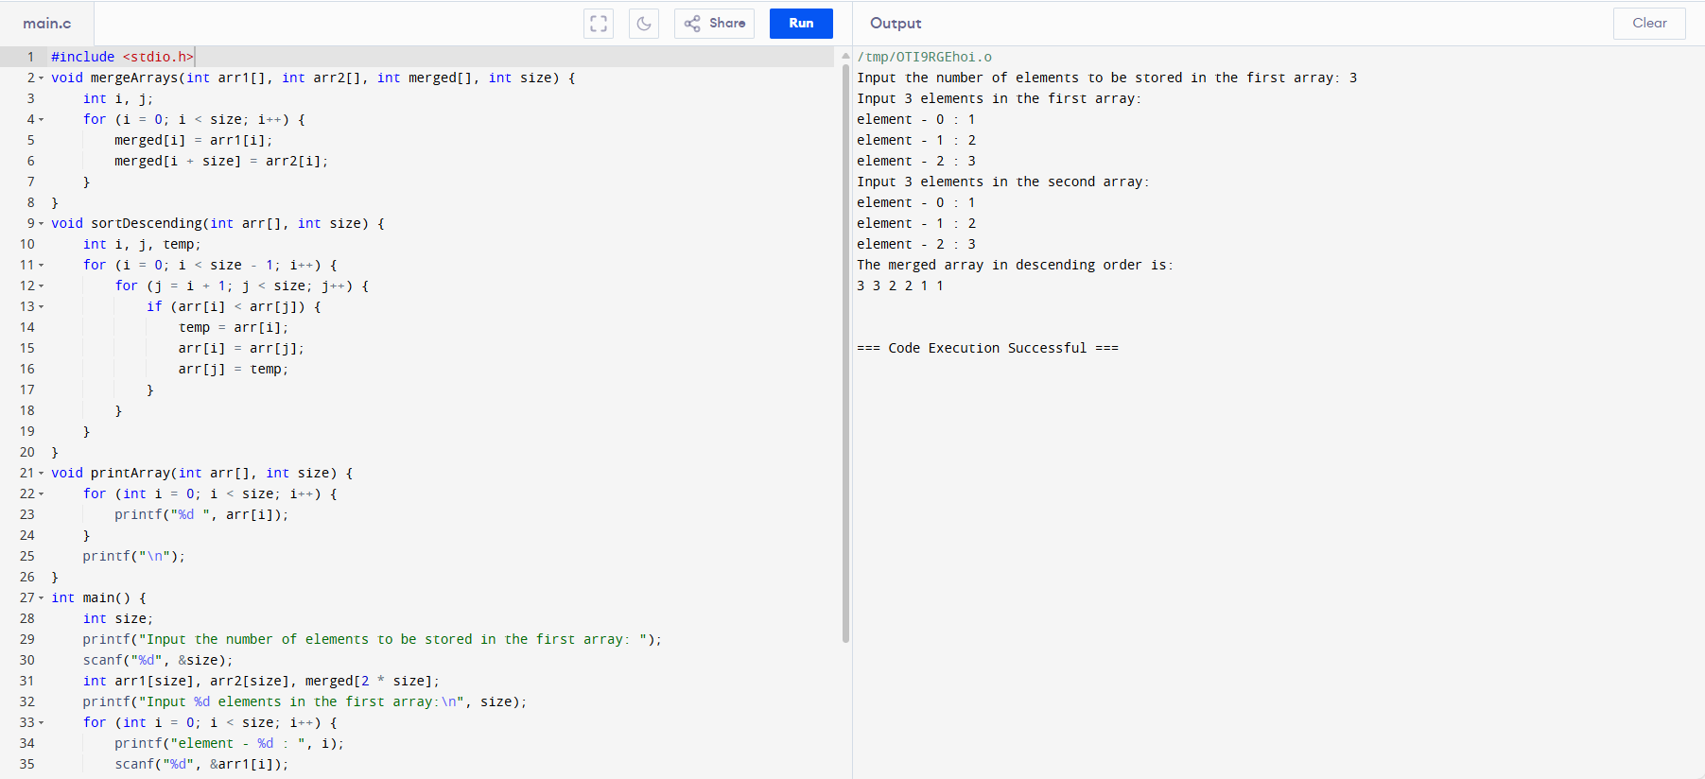

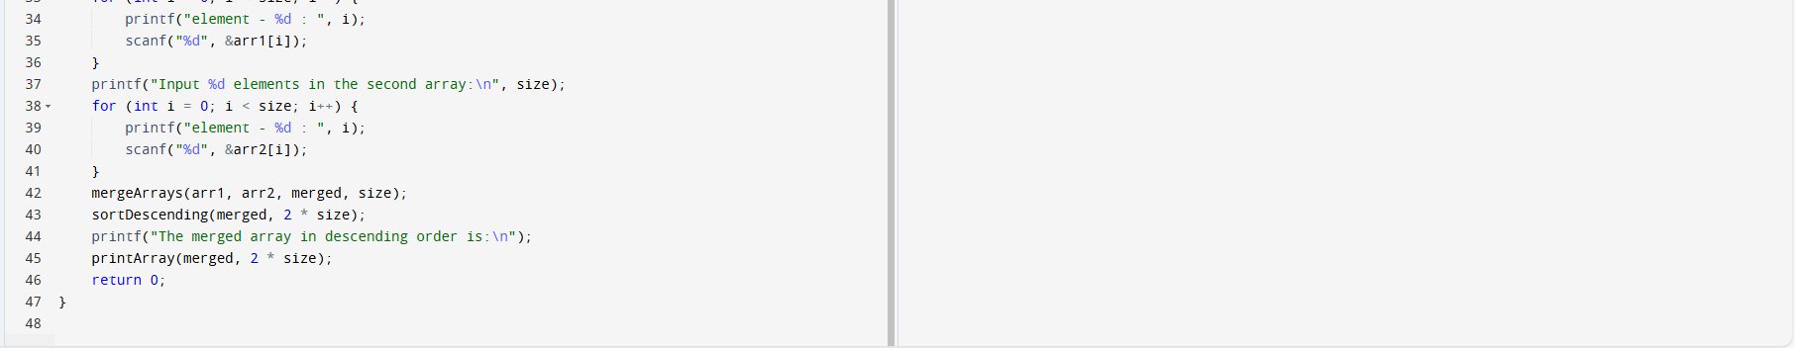

36. Implement a C Program to perform Tree traverse – Inorder, Preorder and Postorder.

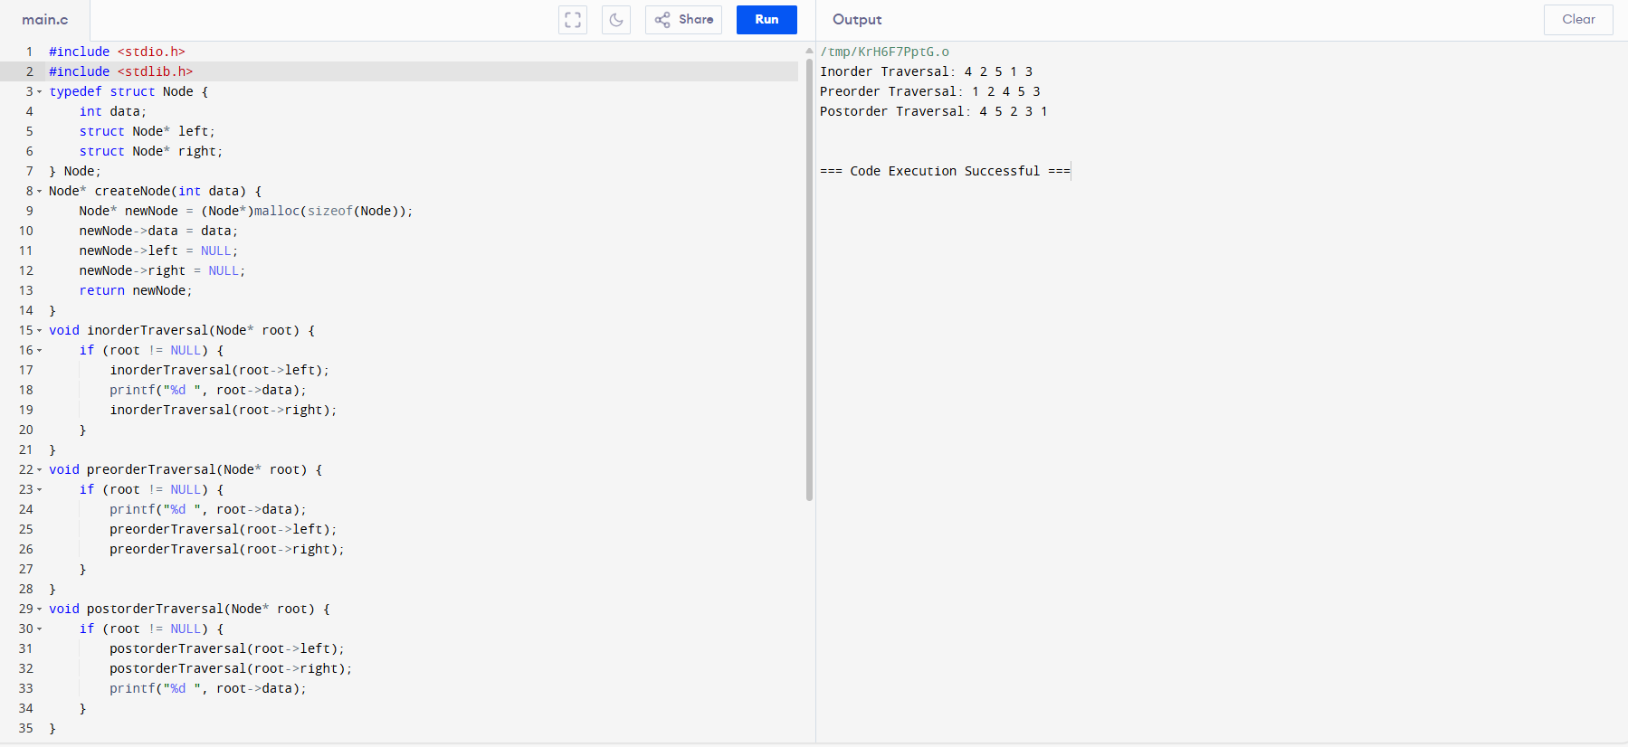

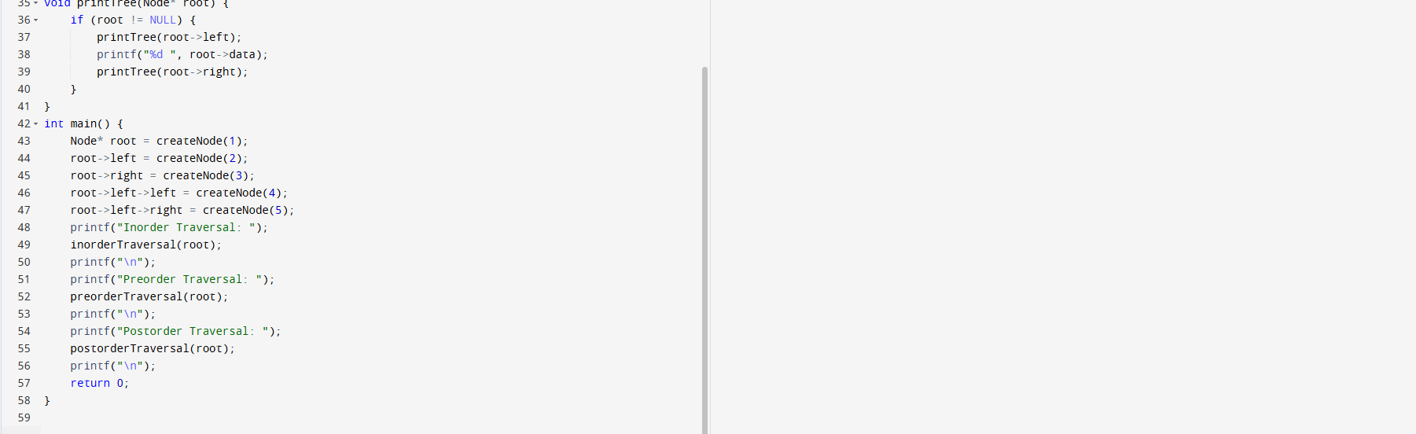

37. A Implement a C Program to perform search for unsorted elements.

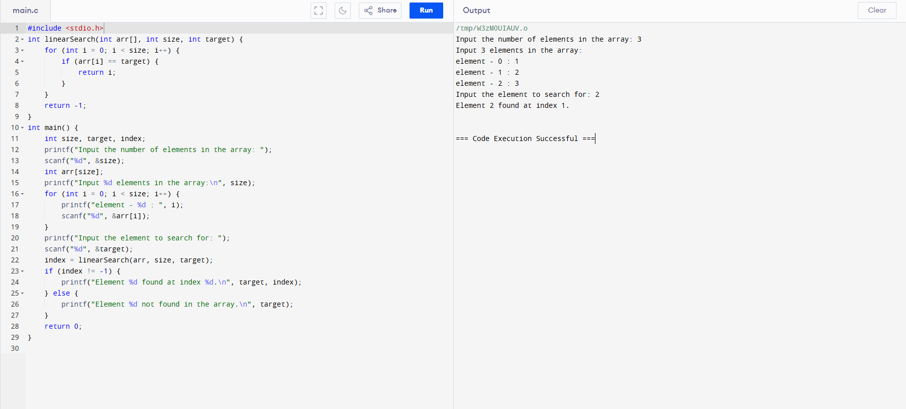

38. . Implement a C Program for a Binary Search Tree - kth min value.

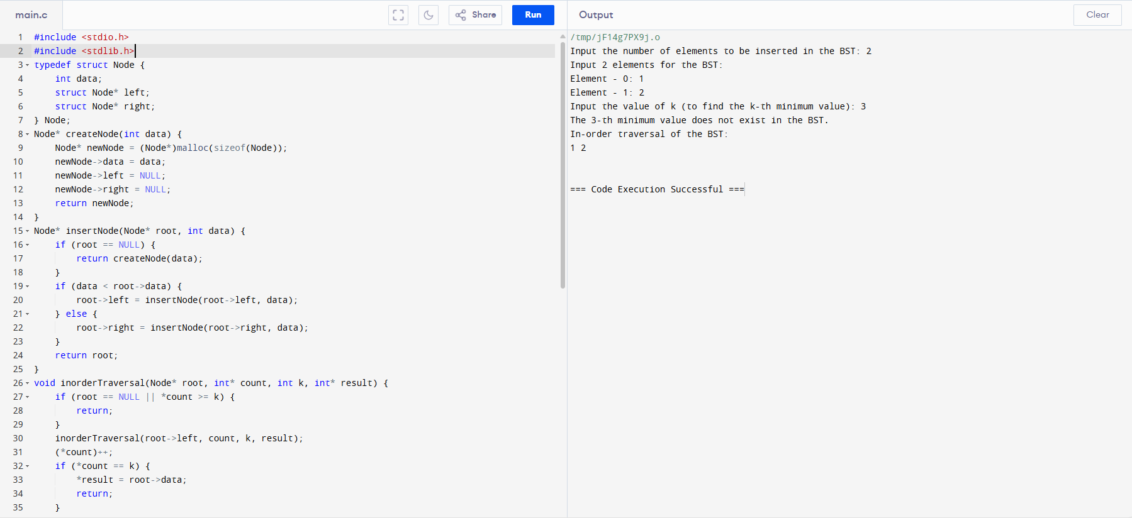

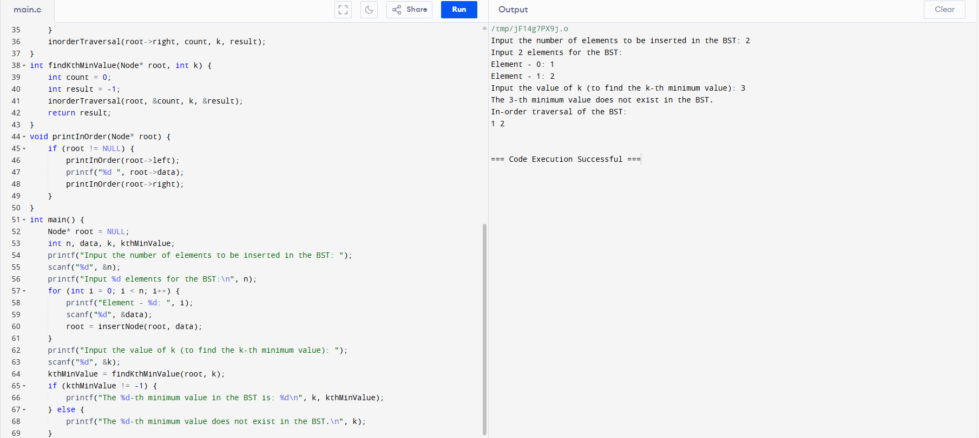



39. Implement a C Program for Given 2 D matrix to print largest element.

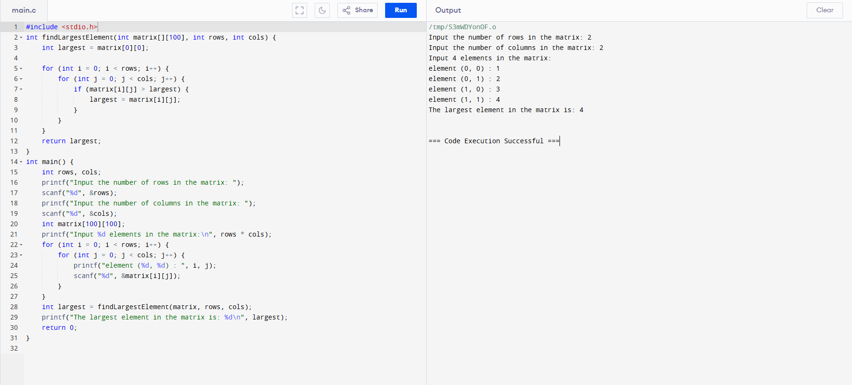

40. Implement a C Program to perform linked list – Insertion.

